**Adding API’s to APIM instance**

By Default, ECHO API and two products (Starter and Unlimited) are configured in APIM instance. To create a new API.

1. Under API section, click “Add API” from the left side menu items.
2. Select the source from where you want to import the operation. There are separate options for importing Logic App, Function App and API App.

**Logic App (Get Customer):**  Select the Logic App and specify the required details in the specified section.

**Function App (Get Products):** Select the Function App and specify the required details in the specified sections.

**SOAP App (Get Orders, Get OrderLines):** Select API App and specify the required details in the specified sections.

Select the Products from the list (It will display default and custom products if created any).

Specify API URL suffix that will be used to uniquely identify the API for further use.

**Select API source**

**Adding Logic-App API to APIM Instance**

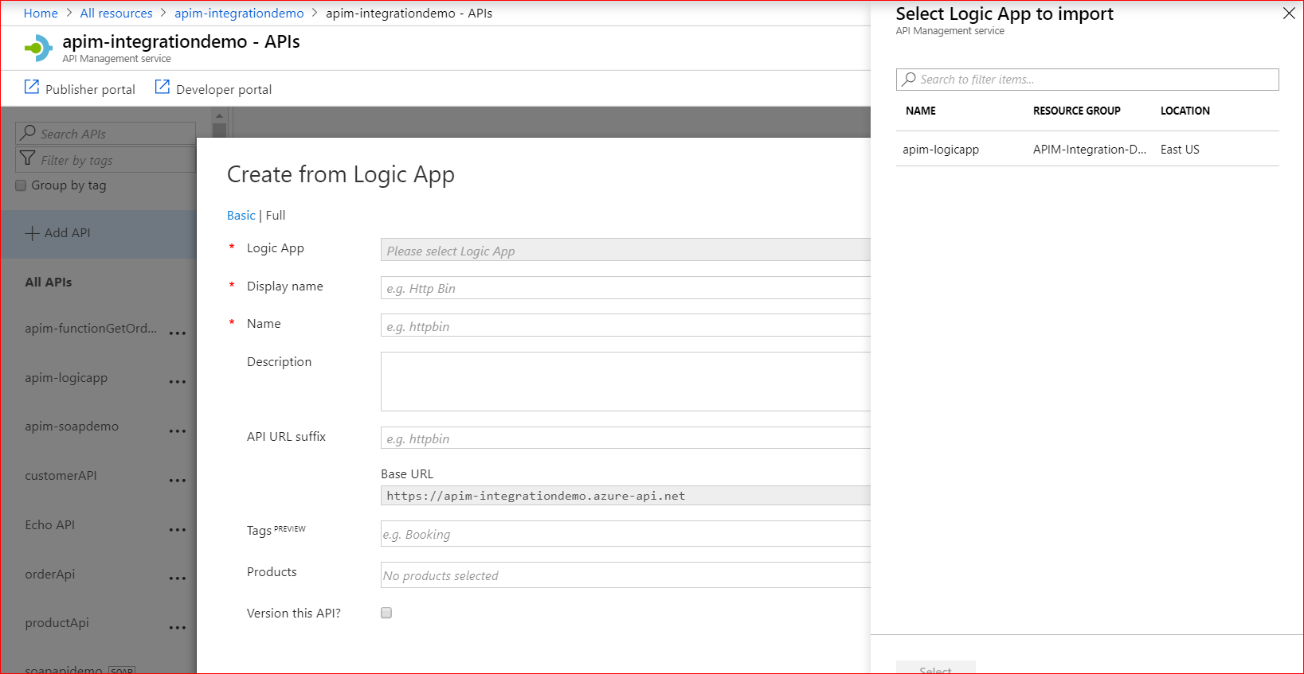

**Adding Azure Function API to APIM Instance**

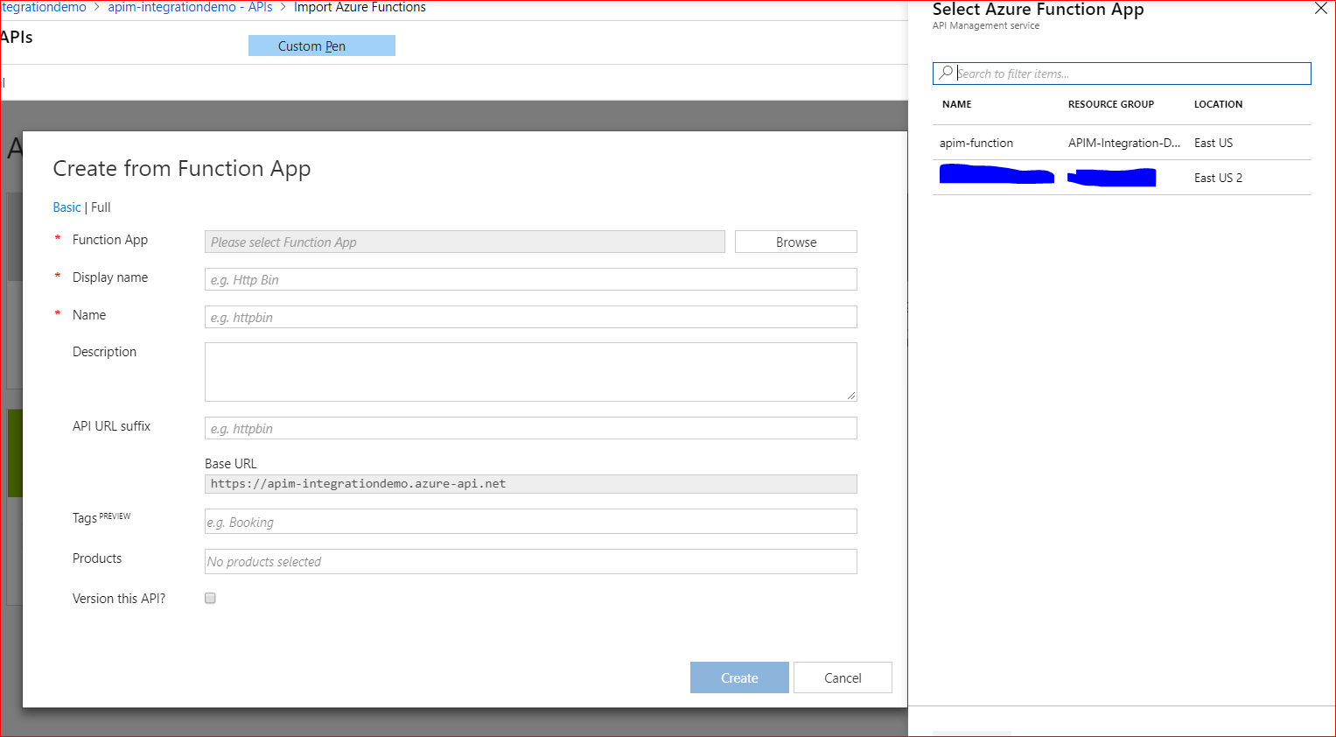

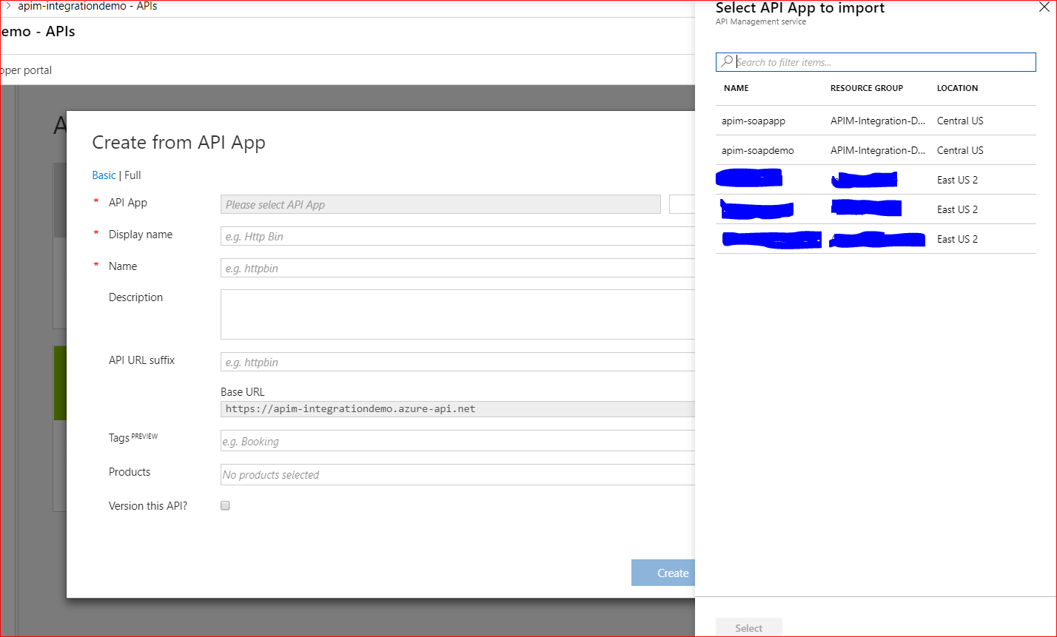

**API Details**

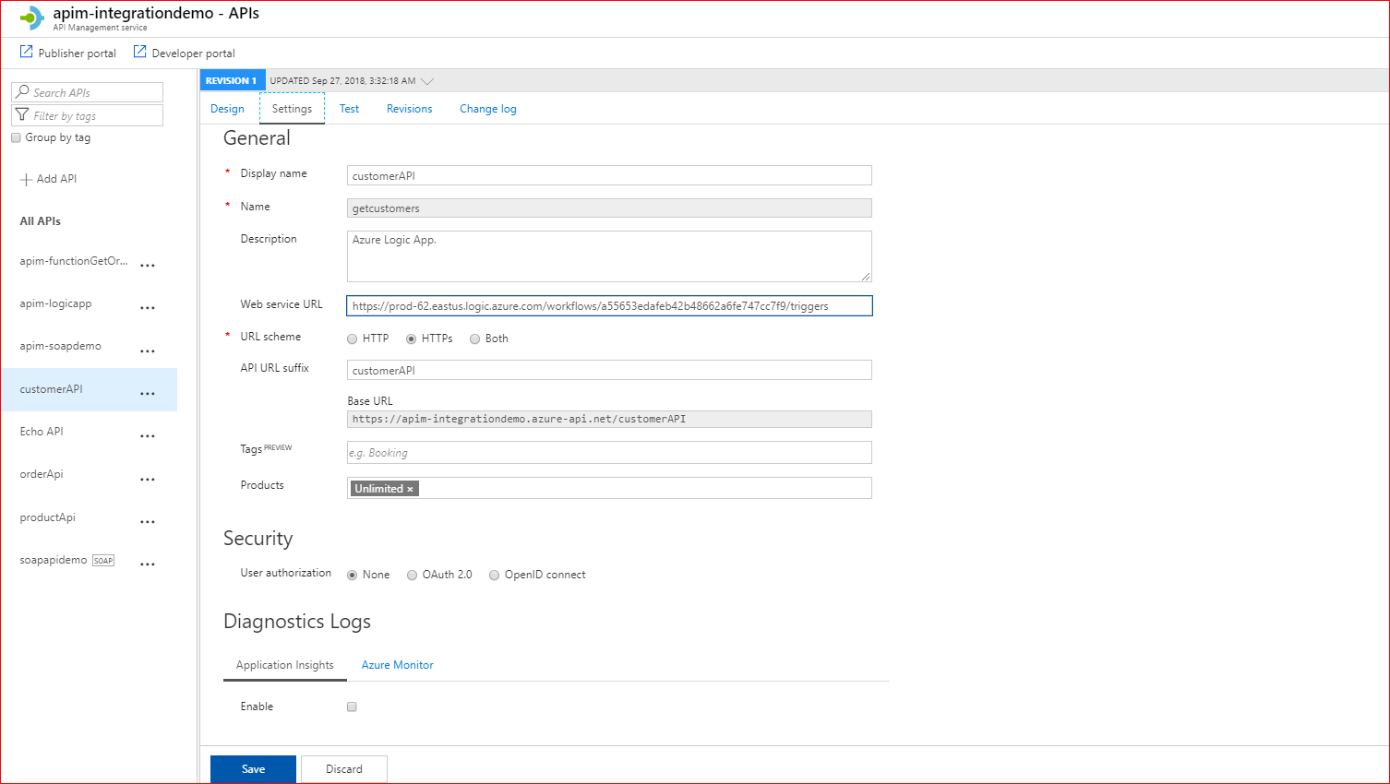

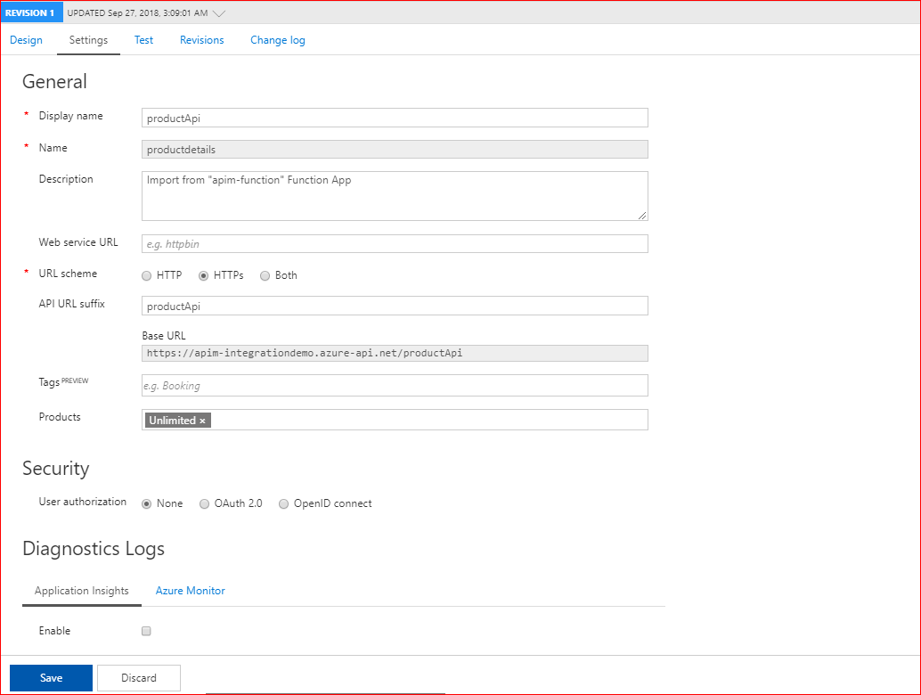

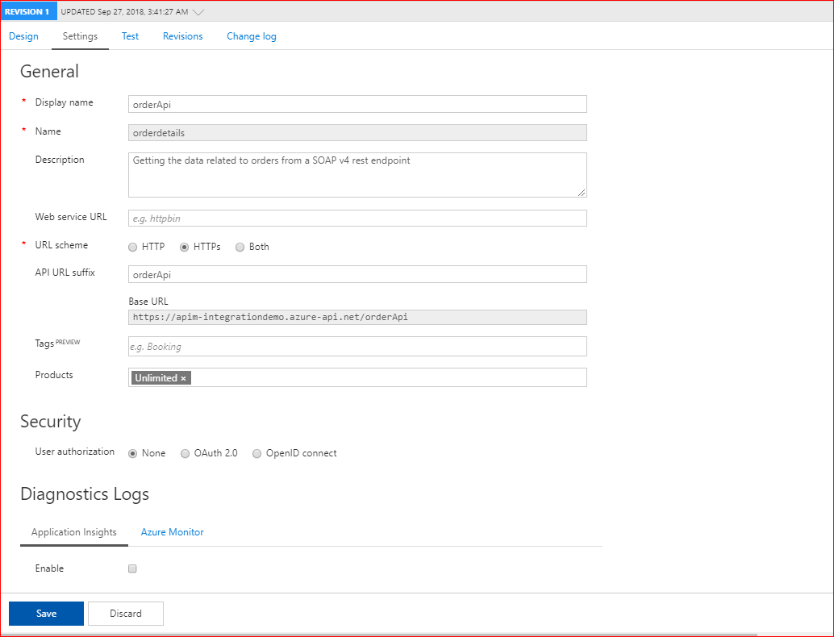

**Operation Details**

When a Logic App is imported then it fetches all the details regarding the operation, request method and request format along with response and Policies that will be applied to requests that are going through APIM. While for others, user need to specify the request/ response and policies as per requirement. User can anytime change the imported settings.

For Function App, it imports the operation for both GET & POST request methods.

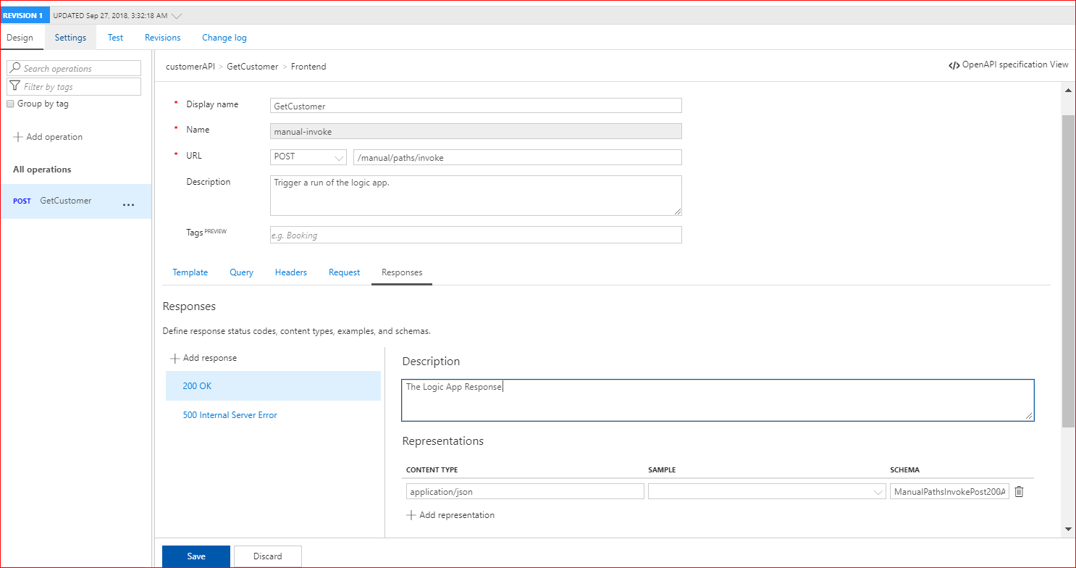

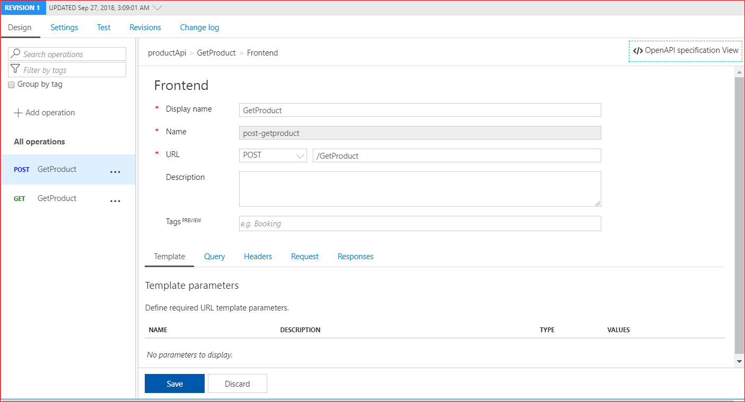

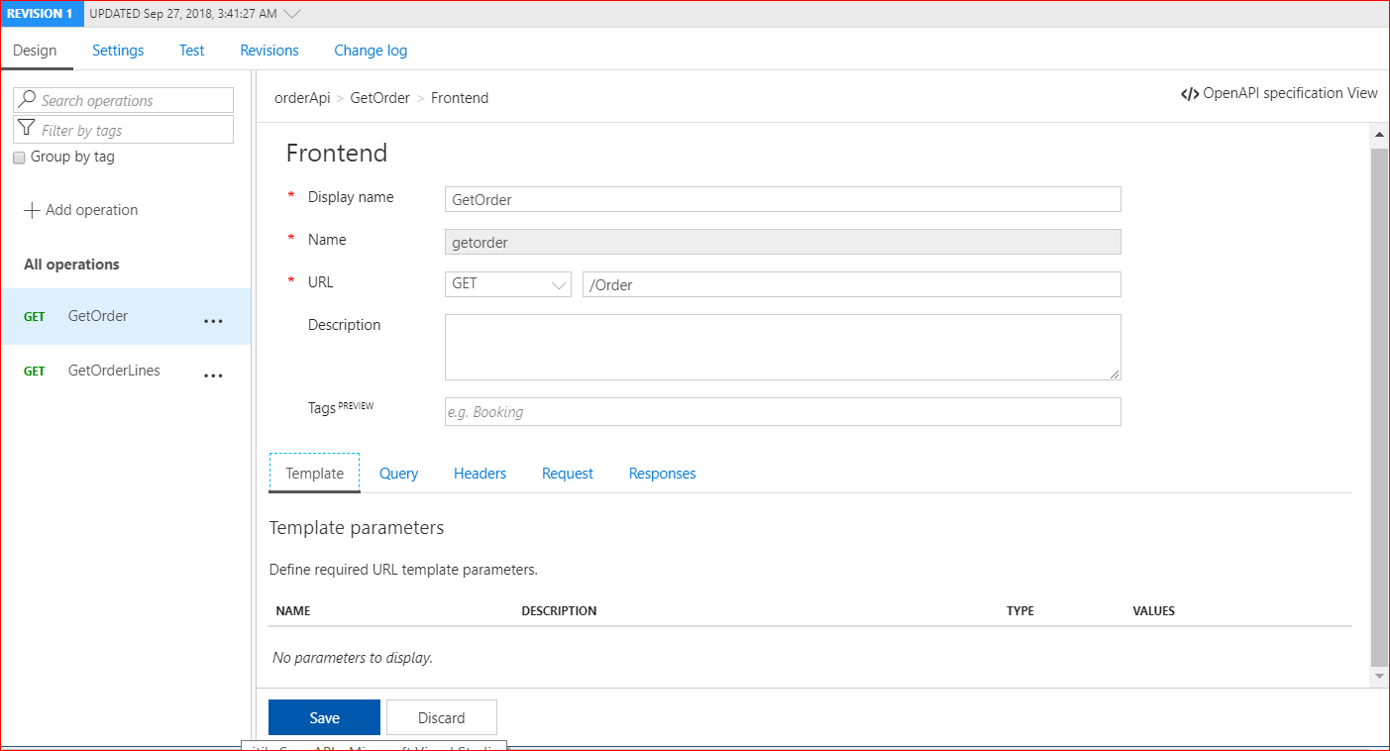

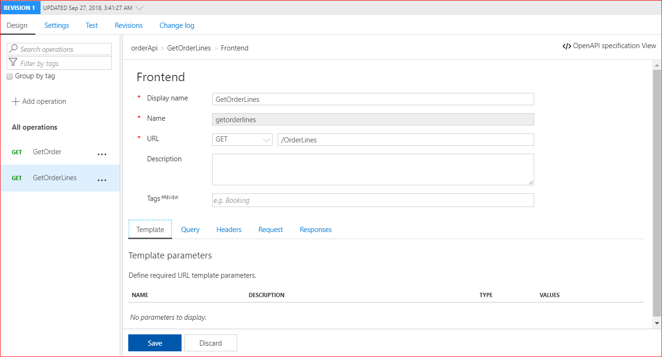

**Policy Details**

